TSRC Workshop: Platinum Group Metal and Platinum Group Metal-free Electrocatalysts: Diagnostics, Modeling and Characterization,
Telluride, March 17 - 21, 2025

Sunday - March 16: from 5:00-6:30 Alibi at 157 S. Fir Street.

The workshop now will be at the fully restored and re-built Telluride Depot:
Telluride Science & Innovation Center, 300 S Townsend St. Telluride, CO 81435

Monday all Day - March 17: 8:00 AM to 4:40 PM
8:00 ********************************** Breakfast*************************************
8:30 Svitlana Pylypenko (Colorado School of Mines): welcome & technical scope
8:45 Pinhead Institute at Telluride – introducing Scholars in the School program.
9:00 Chris Capuano (NEL Hydrogen)
9:40 Iryna Zenyuk (University of California Irvine)
10:20 ********************************** Coffee Break*************************************
10:40 Björn Stühmeier (Bosch)
11:20 Svitlana Pylypenko (Colorado School of Mines)
12:00 **********************************Lunch Break**************************************
1:30 Marian Chatenet (University of Grenoble-Alps, Grenoble INP, LEPMI)
2:10 Peter Strasser (Technical University Berlin)
3:30 ********************************** Coffee Break*************************************
3:50 Karl Mayrhofer (Friedrich–Alexander University, Erlangen–Nürnberg)
4:30 Andrea Baricci, (Milano Polytechnic)
5:10 ********************************** Adjourn*******************************************

Tuesday Morning - March 18: 8:00 AM to 12:10 PM
8:00 ********************************** Breakfast*************************************
8:30 Christina Roth (University Bayreuth)
9:10 Petr Krtil (J. Heyrovsky Institute of Physical Chemistry)
9:50 Slavomir Nemsak (Lawrence Berkeley National Laboratory)
10:30 ********************************** Coffee Break*************************************
10:50 Jakub Drnec (European Synchrotron Radiation Facility)
11:30 Jennifer Peron (City University of Paris)
12:10 ********************************** Adjourn******************************************

Wednesday Morning - March 19: 8:00 AM to 12:10 PM
8:00 ********************************** Breakfast*************************************
8:30 Piotr Zelenay (Los Alamos National Laboratory)
9:10 Ulrike Kramm (Technical University of Darmstadt)
9:50 ********************* Coffee Break and Adjourn***********************************
10:10 Stefania Specchia (Turino Polytechnic)
10:50 Nadezda Kongi (University of Tartu)
11:30 Lior Elbaz (Bar Ilan University)
12:10 ********************************** Adjourn******************************************

5:00 Donor Reception at the Telluride Innovation Center.
6:00 Panel Discussion: Fueling the Future: The Hydrogen Economy.
Panelists: Iryna Zenyuk (University of California Irvine)
Christina Roth (University Bayreuth)
Karl Mayrhofer (University, Erlangen–Nürnberg )
Chris Capuano (NEL Hydrogen)
Lior Elbaz (Bar Ilan University)
Björn Stühmeier (Bosch)

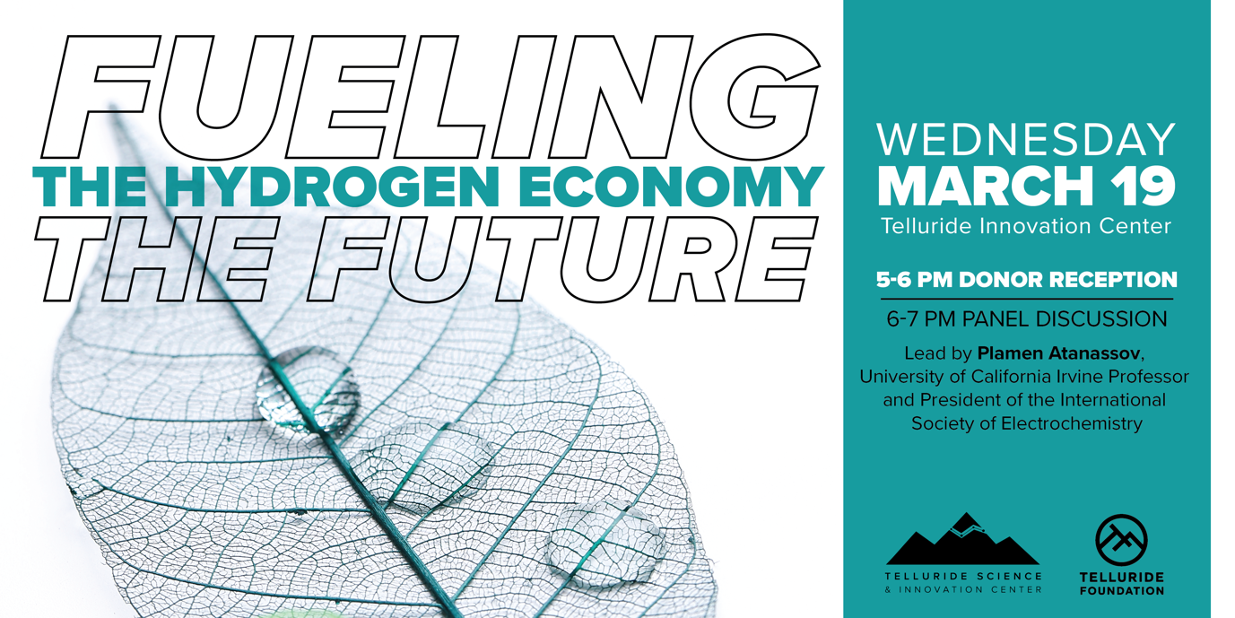

Thursday Morning - March 20: 8:30 AM to 12:00 PM
8:00 ********************************** Breakfast*************************************
8:30 Stoyan Bliznakov (University of Connecticut)
9:10 Phillip Röse (Karlsruhe Institute of Technology)
9:50 ********************************** Coffee Break*************************************
10:10 Haoran Yu (Oak Ridge National Laboratory)
10:50 Plamen Atanassov (University of California Irvine)
11:30 Discussion and Closing Remarks
12:00 ********************************** Adjourn******************************************

Thursday, March 20: 6:30 PM – at the Oak -social dinner.

Friday, March 21: All day networking and proposal building.

